Unit 3达标测试卷

时间：40分钟　满分：100分

听力部分 (40分)

一、听录音，选出你听到的选项。(10分)

(　　) 1. A. children　　　　　 B. child　　　　　　　 C. woman

(　　) 2. A. no B. so C. zoo

(　　) 3. A. water B. short C. elephant

(　　) 4. A. foot B. cat C. fat

(　　) 5. A. big B. bag C. book

二、听录音，选出与录音内容相符的图片。(10分)

(　　) 1. A. 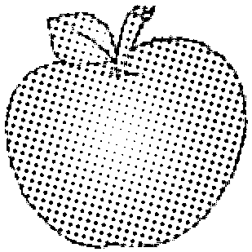　　　　　　　　　　　　 B. 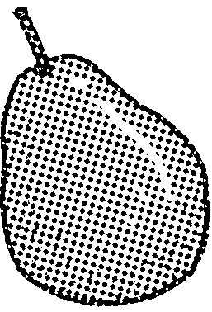

(　　) 2. A. 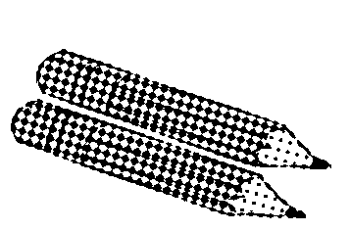 B. 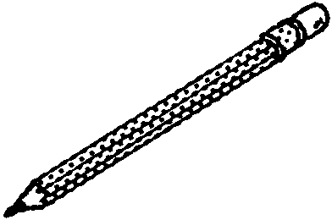

(　　) 3. A. 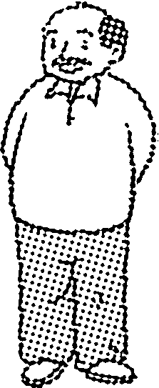 B. 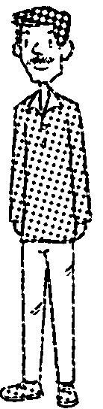

(　　) 4. A. 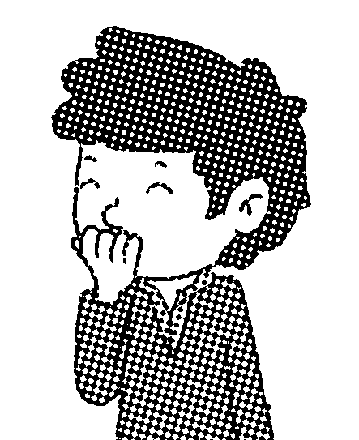 B. 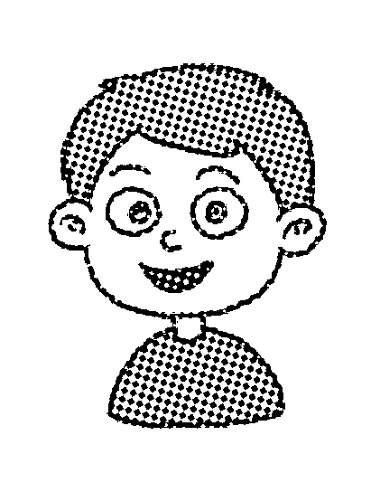

(　　) 5. A. 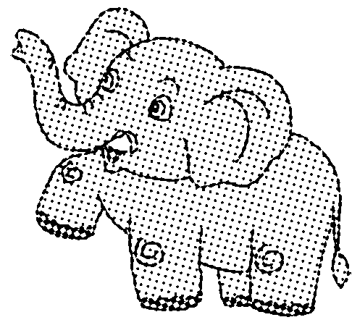 B. 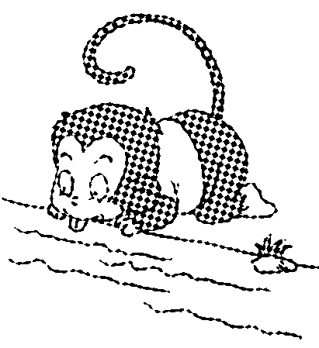

三、听一听，根据你听到的内容给下面句子标上序号。(10分)

(　　) Come here, Amy!

(　　) That boy has small eyes and big ears.

(　　) It has a long nose and a short tail.

(　　) How many animals do you know?

(　　) I see a cat.

四、听录音，选词完成句子。(10分)

(　　) 1. Mike has a big ________.

A. nose　　　　 B. mouth　　　　　　　 C. eyes

(　　) 2. Tom's grandfather has ________ ears.

A. big B. small C. pig

(　　) 3. Don't feed the ________.

A. animals B. monkeys C. pencils

(　　) 4. The fat man is my ________.

A. mother B. father C. brother

(　　) 5. That panda is black and________.

A. white B. fat C. short

笔试部分 (60分)

五、判断下列每组句子中的单词，画线字母的读音是(√)否(×)相同。(5分)

(　　) 1. I have six pigs, two dogs and six hens.

(　　) 2. Look at this tiger. It's so fat.

(　　) 3. My dog is thin and big.

(　　) 4. I don't like big animals.

(　　) 5. The fish has a big tail.

六、选出与所给单词不同类的一项。(5分)

(　　) 1. thin A. fat　　　　　 B. long　　　　　 C. your

(　　) 2. short A. big B. hand C. small

(　　) 3. elephant A. foot B. monkey C. panda

(　　) 4. milk A. water B. juice C. gift

(　　) 5. eye A. head B. tail C. black

七、趣味连线。(5分)

1. 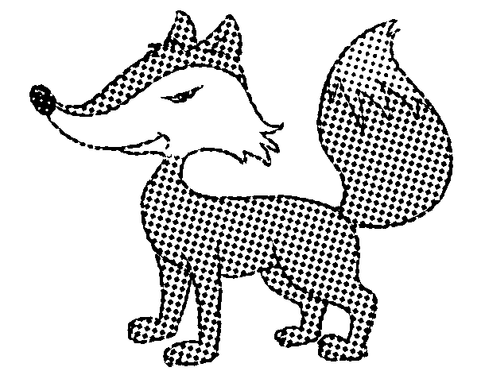　 2. 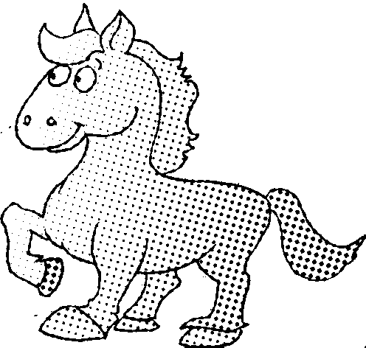　 3. 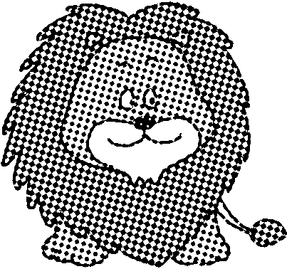　 4. 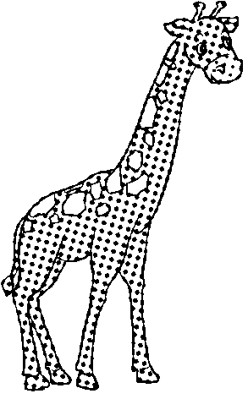　 5. 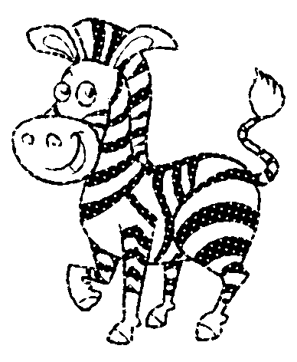

A. a short horse　 B. a thin fox　 C. a fat zebra　 D. a big lion　 E. a tall giraffe

八、从下列所给字母中圈出你认识的单词，并写在后面的四线三格内。(5分)

1. h o r m i l k s o x  2. g o r g i f t p a d 

3. h o r s m a l l o g  4. h a v a r s h o r t 

5. a n i m e l t h i n　

九、按要求写单词。(5分)

1. small(反义词) ________ 2. thin(反义词) ________

3. children(单数形式) ________ 4. eye(复数形式) ________

5. have(第三人称单数) ________

十、看图片，选择对应的句子，并把其字母标号写在括号中。(5分)

1. 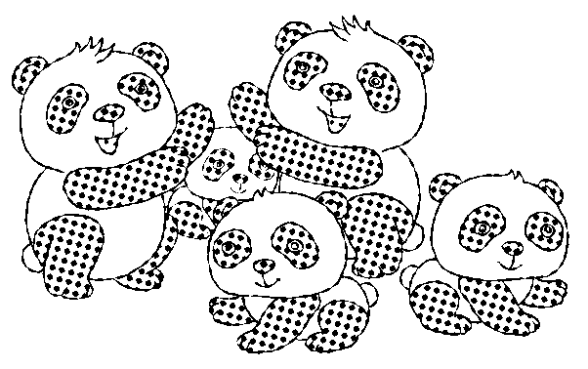　　2. 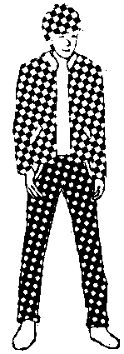　　　3. 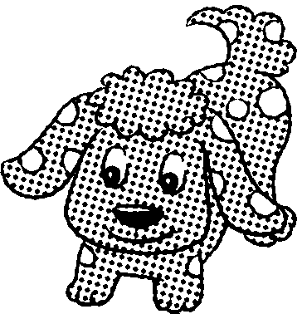　　　4. 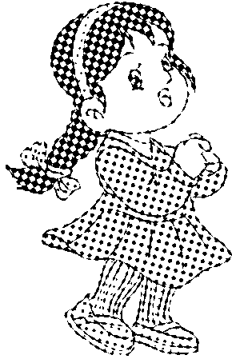　　　5. 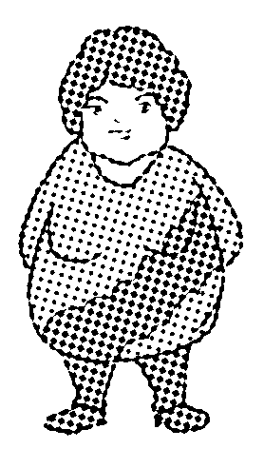

　 (　　)　 　　 (　　)　 　 (　　)　　 　 (　　)　　 　(　　)

A. The fat woman is Lily's mother. 　　　B. I see some pandas. They are so cute!

C. The beautiful girl is Sarah's sister. D. The tall boy is my brother.

E. That dog is black and white.

十一、单项选择。(5分)

(　　) 1. Look！The elephant ________ a long nose.

A. have　　　　　　 B. has　　　　　　 C. are

(　　) 2. Look ________ the dog.

A. at B. / C. on

(　　) 3. Amy has big ________and a small mouth.

A. eyes B. eye C. an eye

(　　) 4. The cat is short and the giraffe is ________.

A. long B. small C. tall

(　　) 5. I have ______bird，______ cat and ______ dog.

A. a; an; a B. a; a; a C. a; a; an

十二、情景交际。(5分)

(　　) 1. 你想形容你的爷爷又高又瘦，你可以这样说：

A. My grandfather is tall and thin.

B. My grandmother is tall and thin.

(　　) 2. 你想表达动物们很可爱，你可以这样说：

A. They are cute!

B. They are beautiful!

(　　) 3. 你想问同桌知道多少种鸟，你可以这样说：

A. How many animals do you know?

B. How many birds do you know?

(　　) 4. 你想告诉你的朋友，你们看到的动物，大的是狼，小的是狐狸，你可以这样说：

A. The big one is a wolf and the small one is a cat.

B. The big one is a wolf and the small one is a fox.

(　　) 5. 你认为你的朋友说得对，你可以这样说：

A. Good! B. Right!

十三、选出与句子中画线单词对应的选项，将其序号写在括号里。(5分)

A. long　　B. thin　　C. small　　D. short　　E. black

(　　) 1. The elephant is big.

(　　) 2. The pencil is short.

(　　) 3. Tom's father is very fat.

(　　) 4. My brother is tall.

(　　) 5. The fox is white.

十四、根据<A>栏中的句子，在<B>栏中选出正确答语。(5分)

<A> <B>

(　　) 1. How many small cats?　　　　　　　 A. Here you are.

(　　) 2. I'd like a fat dog, please. B. OK!

(　　) 3. Don't feed the dog! C. Great!

(　　) 4. Let's go to the zoo. D. Ah, it's so cute!

(　　) 5. Look at the fox. E. Six.

十五、对话填空，将正确选项的字母填到括号里。(5分)

A. they're so cute　　 B. It has a long tail　　 C. Come on

D. And it's cute E. The monkey is eating bananas

(　　) 1. ________， Sarah! Look at the foxes.

(　　) Oh, 2. ________ ! I like them.

(　　) I like the monkey! 3. ________.

Yes. And it has a big mouth.

(　　) Look! 4. ________！It's so funny! Ha! Ha!

(　　) Yes. 5. ________ too.

十六、阅读短文，根据内容判断对(√)和错(×)。(5分)

Hi，I'm Amy. I am a girl. I like the zoo. In the zoo, I can see monkeys, elephants, foxes, pandas and tigers. Look! The fox has a long tail. Wow! The elephant is so big. It has small eyes and big ears. It has a short tail and a long nose.

(　　) 1. Amy likes the zoo.

(　　) 2. Amy is a boy.

(　　) 3. The panda has a long tail.

(　　) 4. Amy can see foxes in the zoo.

(　　) 5. The elephant has a long nose and small eyes.

Unit 3达标测试卷

听力材料：

一、1. children 2. so 3. short 4. fat 5. big

二、1. The apple is big.

2. The pencil is long.

3. My grandfather is so thin.

4. The boy has small eyes.

5. It has a long nose.

三、1. It has a long nose and a short tail.

2. I see a cat.

3. That boy has small eyes and big ears.

4. How many animals do you know?

5. Come here, Amy!

四、1. Mike has a big mouth.

2. Tom's grandfather has big ears.

3. Don't feed the animals.

4. The fat man is my brother.

5. That panda is black and white.

答案：

一、1. A　2. B　3. B　4. C　5. A

二、1. A　2. B　3. B　4. A　5. A

三、5　3　1　4　2

四、1. B　2. A　3. A　4. C　5. A

五、1. √　2. ×　3. √　4. ×　5. √

六、1. C　2. B　3. A　4. C　5. C

七、1—B　2—A　3—D　4—E　5—C

八、1.  

2.  

3.  

4.  

5. 　 

九、1. big　2. fat　3. child　4. eyes　5. has

十、1. B　2. D　3. E　4. C　5. A

十一、1. B　点拨：have, has都表示“有”。has用在第三人称单数后面；have用于第一人称、第二人称后面。

2. A　点拨：look的意思是“看”，强调看的动作。当要看具体东西或人时，需要加“at”。

3. A

4. C

5. B　点拨：a应该放在以辅音音素开头的名词或其修饰语前，而an则放在以元音音素开头的名词或其修饰语前，句中都是以辅音音素开头的单词，所以用a。

十二、1. A　2. A　3. B　4. B　5. B

十三、1. C　2. A　3. B　4. D　5. E

十四、1. E　2. A　3. B　4. C　5. D

十五、1. C　2. A　3. B　4. E　5. D

十六、1. √　2. ×　3. ×　4. √　5. √